(22nd November 2024)

STATE CENTRE OF EXCELLENCE
DEPT OF PEDIATRICS, AIIMS, RAIPUR

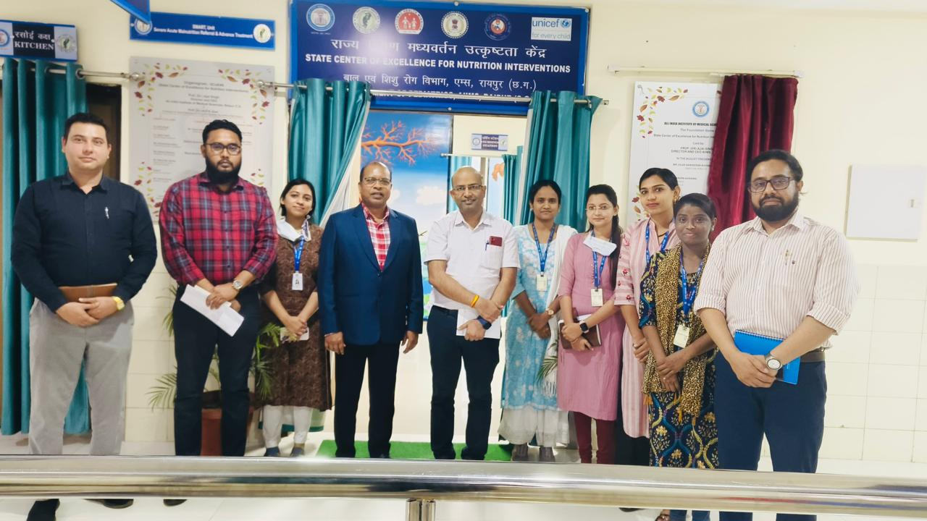

REPORT ON VISIT BY: COMMON REVIEW MISSION

22nd NOVEMBER 2022

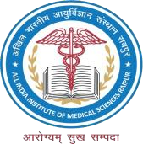
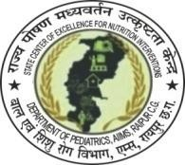
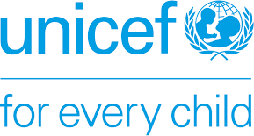
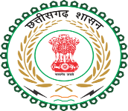
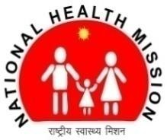


BACKGROUND:

Common Review Mission (CRM) has been a robust mechanism under National Health Mission to monitor the implementation of NHM strategies. Over the years CRM has played a critical role in reviewing the ongoing and newer initiatives of GoI, to strengthen the health system. It also provides a clear picture on preparedness of systems towards implementation and roll out of recent intervention under NHM.

TEAM:

Name | Designation
Dr. Vaibhav Rastogi  Public Health (MD, PGDHHM, MBBS) | Lead Consultant - Child Health Division  Ministry of Health and Family Welfare, Government of India
Dr. VR Bhagat | MD, NHM, Chhattisgarh
Dr. Ak Goel | Prof and HOD, Dept of Pediatrics, Program Director SCoE4N,AIIMS Raipur
Mr. Mumtaz Ansari | Maternal Child Health Nutrition Consultant, UNICEF, C.G
Dr. Surabhi Nayak | Medical officer, FSAM SCoE4N, AIIMS, Raipur
Dr. Nagma Shah | State IYCF Consultant, SCoE4N, AIIMS, Raipur
Mr. John Varun Alexander | State Project coordinator, CSAM SCoE4N, AIIMS, Raipur
Mr. Vishnu Pandey | State Admin Coordinator, SCoE4N, AIIMS, Raipur
Ms. Dhaleswari Sahu | State Lactational Consultant , SCoE4N, AIIMS, Raipur
Ms. Pooja | Feeding Demonstrator, SCoE4N, AIIMS, Raipur,
Mrs. Kirti | Cook cum Caretaker, SCoE4N, AIIMS, Raipur
Ms. Usha | Cook cum Caretaker, SCoE4N, AIIMS, Raipur
Mr. Harish | Attender , SCoE4N, AIIMS, Raipur

CONTEXT:

Date: 22.11.24, Friday.

Place: SMART unit, State Centre of Excellence, Dept. of Pediatrics, AIIMS, District Raipur, C.G.

OBJECTIVES:

- To understand the best practices of SCoE4N
- To understand the developed strategies and its implementation (SMART UNIT)

THE PRACTICE:
To assist the state government in its goal of malnutrition-free and Anaemia free Chhattisgarh by improving the Infant and Young Child feeding practices in the state, skilled management of children with severe acute malnutrition through facility and community care including growth faltering in under 6 months infants, SCOE4N was established in 2019 at the All-India Institute of Medical Sciences (AIIMS) Raipur, with support from the NHM and UNICEF.

The centres key objectives are to improve rates of early breastfeeding initiation and exclusive breastfeeding, strengthen management of SAM through facility and community care, establish data monitoring systems to track SAM management outcomes, to serve as a referral centre for complicated SAM cases through the SMART (Severe Acute Malnutrition Referral & Advance Treatment Unit, to undertake research and to provide training and capacity building for healthcare providers.

Facility-based management of Severe Acute Malnutrition (FSAM), focuses on providing specialized care to children with SAM within healthcare facilities, including comprehensive treatment protocols, therapeutic feeding, medical care, and monitoring to stabilize and rehabilitate severely malnourished children. FSAM ensures timely and intensive management of SAM cases, reducing complications and mortality rates associated with severe malnutrition.
Active screening in the Pediatrics OPD’s has resulted in the identification of missed children in the community and these children were counselled and linked to the nearest facility or Anganwadi centre after giving the primary care.

State of Art Severe Acute Malnutrition Referral & Advance Treatment Unit (SMART Unit) at department of Pediatrics, AIIMS Raipur is an integral part of FSAM and caters to all the complicated SAM children referred from the community AWW with the active involvement of District and Block level Nutrition coordinators (DNC and BNC). Comprehensive management is provided to each children including sensory stimulation and behavioural therapy. Once improved, they are sent back to the respective NRC with an established linkage involving all the stake holders of community and facility level.
The SCoE4N is monitoring all those Children who were discharged from the SMART unit through DNC, BNC and dashboard (Supposhan & Samarthya application)

STRATEGIES DEVELOPED:
- SMART unit Kitchen utilizes the opportunity of the mother/beneficiaries being present for live recipe demonstrations and cooking counselling to the children admitted in the SMART unit.
- Tele-monitoring of NRC, a noble approach to monitor the NRC’s which are in the difficult and hilly areas of the state. Virtual calls (Rosters are shared with NRCs at the previous month) are placed daily to provide technical assistance to any queries related to care, feeding protocol adherence, and other technical support and monthly report is being prepared and shared with NHM & UNICEF.
Over some time, it was observed that the queries of the feeding demonstrators and other functionaries were decreased and the cure rate of the SAM children improved drastically.
- The target is to cover all the NRCs of the state, apart from the regular physical supportive supervision extended by the state coordinators at SCoE4N.

RECOMMENDATIONS:
As a suggestion, Dr. Vaibhav sir mentioned about organising a group counselling via tele monitoring and tele mentoring monthly, with Feeding demonstrators that would help to reach out a larger group in a single mode of communication. Identifying gaps and scaling up of best practices could be leveraged across the state.
Also, Kitchen counselling and recipe demonstration directly to the beneficiaries, a unique concept that could be leveraged and set as an example for coming up with useful strategy and could be presented in national level.

FUTURE DIRECTION:
Based on the experience of the maiden center in the country, which caters to all the important 4
pillars of nutrition intervention, like Facility and community-based management of SAM, CSAM, IYCF, & AMB and implementation of key activities like model NRC (SMART Unit). Telemonitoring of remote NRC’s, Tele mentoring of lactational counselors, smart treatment of complicated SAM Children, Daily OPD screening and establishment of robust linkage with community health workers, the state-run medical colleges can act as such model centers and act like spoke and hub model to combat the malnutrition of the state.

